**Tutorial 6 Answers – Made By U19CS012**

1. Explain two-pass assembler functions with example program.

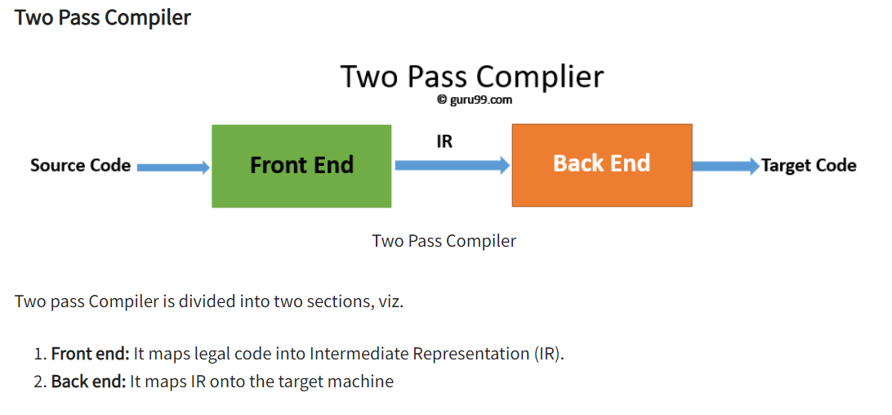

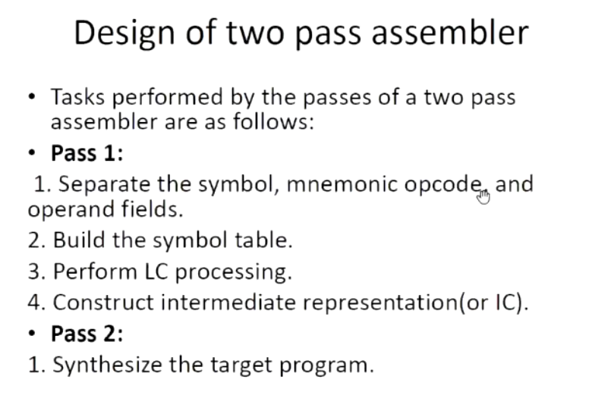

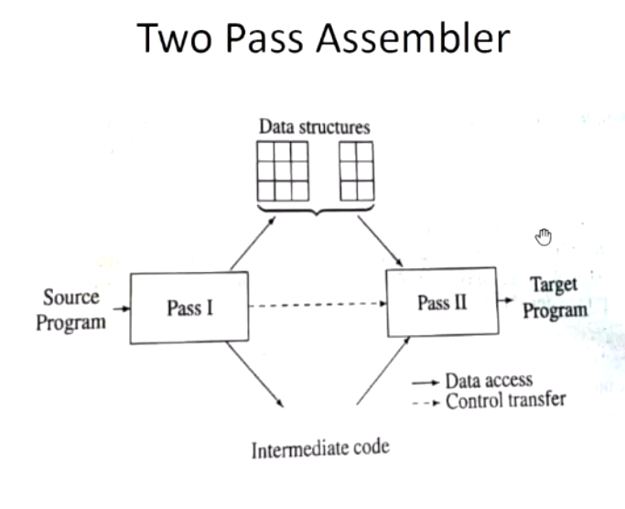

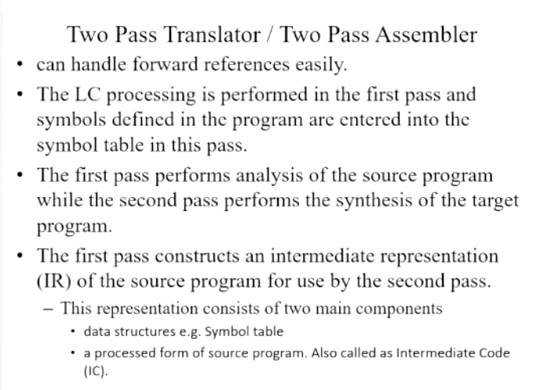

References

1) <https://www.entcengg.com/two-pass-assemblers/>

2. What are some advantages of assembly languages over high level languages?

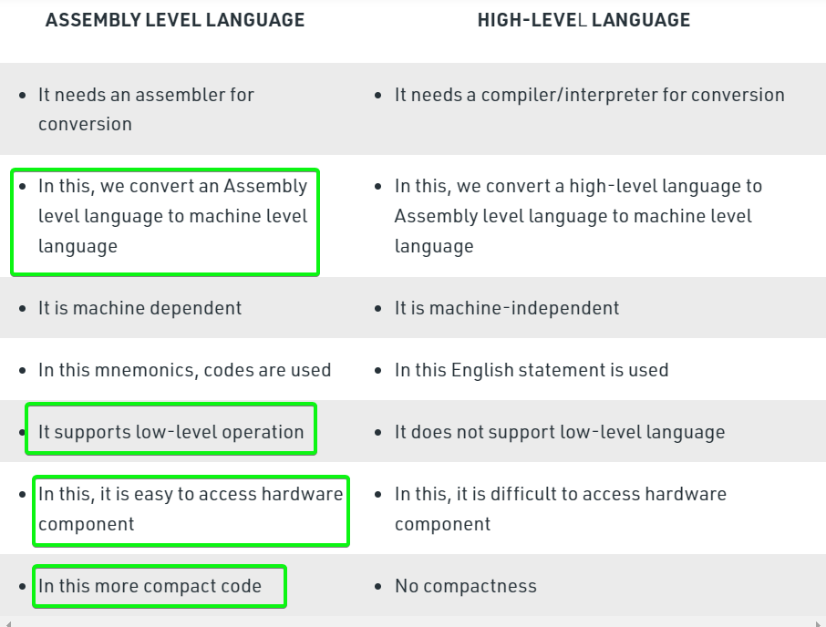

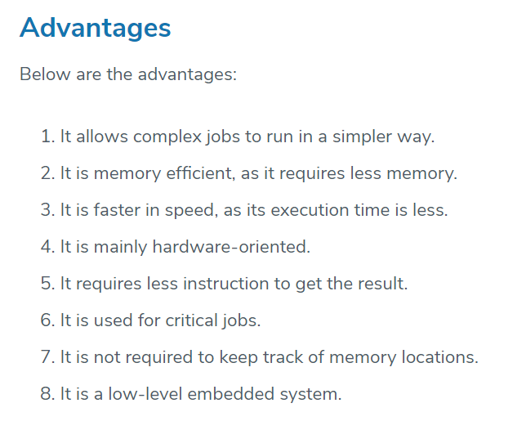

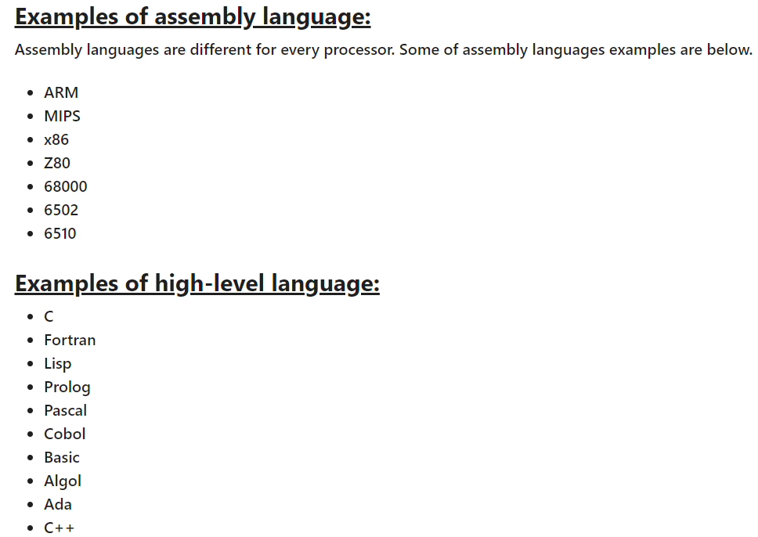

3. What tools are used for compiler construction?

Parser generators - YACC

• Scanner generators – Lex

<https://www.geeksforgeeks.org/compiler-construction-tools/>

<https://ecomputernotes.com/compiler-design/compiler-construction-tools>

4. What are applications of compiler? Explain.

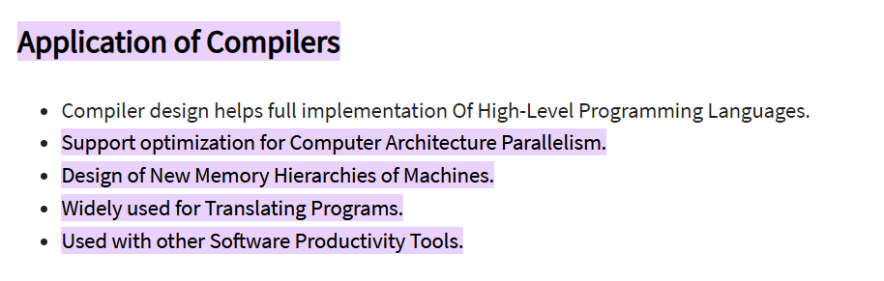

<https://www.geeksforgeeks.org/applications-of-compiler-technology/>

5. Differentiate between a macro and a subroutine. And explain macro definition and expansion using an example.

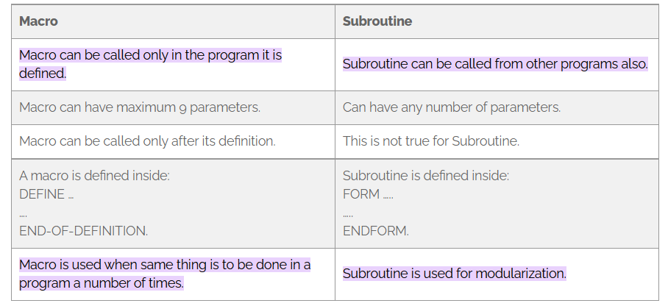

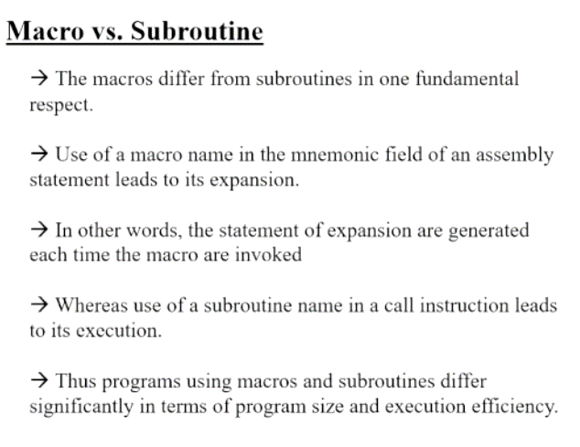

<https://www.geeksforgeeks.org/difference-between-macro-and-procedure/>

<https://www.geeksforgeeks.org/macros-and-its-types-in-c-cpp/>

